Jenkins Notes – Continuous Integration

A big reason this is desired is because developers have to wait for bugs to be tested and then they have to find the bugs, fix the bugs and then test them again. Software delivery process was slow.

With continuous integration if any of the developers makes a push to the Source Code Repository, the code will be pulled, built, tested and deployed. This gives us a huge advantage of knowing what code or commit caused the bug. You no longer need to check all the source code entered, just the specific commit. This also allows for the developers to fix issues quicker and reduces the overall software development time cycle.

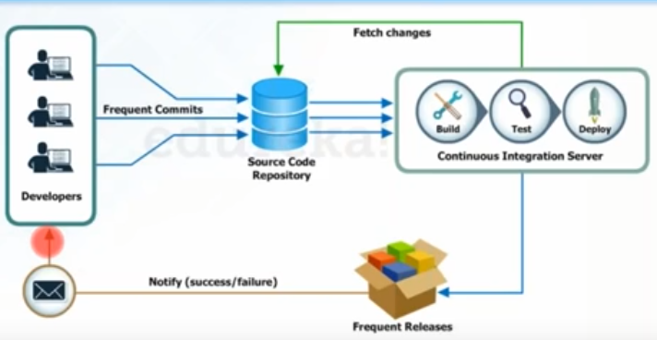

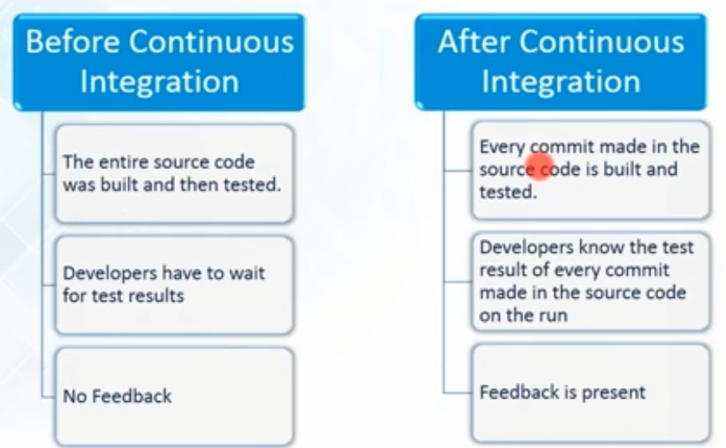

For every commit you make to the source code you are presented with Feedback.

Jenkins uses over 1000 plugins. One of the most widely accepted tool for Continuous Integration.